 |  | 
MINISTRY OF HIGHER EDUCATION, SCIENCE AND INNOVATION OF THE REPUBLIC OF UZBEKISTAN

MINISTRY OF AGRICULTURE OF THE REPUBLIC OF UZBEKISTAN

INTERNATIONAL INSTITUTE OF FOOD TECHNOLOGY AND ENGINEERING

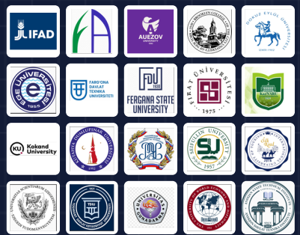 | 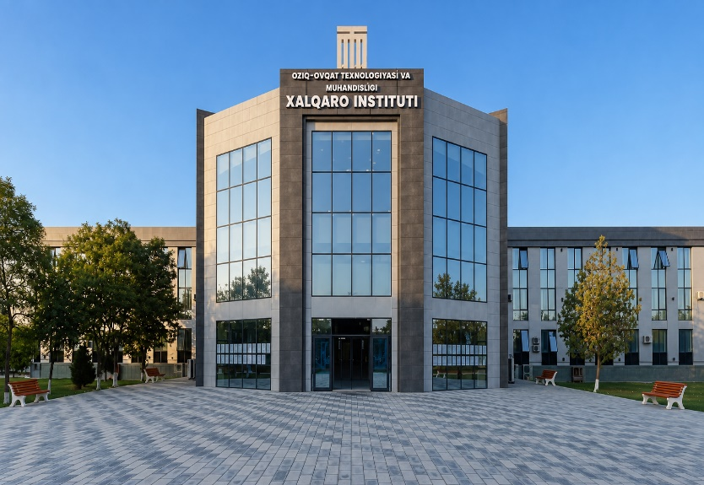

INDUSTRIAL TRANSFORMATION, ENGINEERING INNOVATIONS AND NEW DIRECTIONS FOR SUSTAINABLE ECONOMIC GROWTH

International Scientific and Practical Conference

23–24 October 2026

Fergana – 2026
INFORMATION LETTER

Pursuant to Order No. 11 of the Minister of Higher Education, Science and Innovation of the Republic of Uzbekistan dated 16 January 2026, the International Institute of Food Technology and Engineering will host the International Scientific and Practical Conference, “Industrial Transformation, Engineering Innovations and New Directions for Sustainable Economic Growth,” on 23–24 October 2026.
Scientific Scope, Aim and Objectives of the Conference
The Conference is focused on the comprehensive scientific analysis of new paradigms of industrial transformation, engineering innovations, the impact of digital and environmentally sustainable technologies on economic growth, and contemporary forms of international industrial cooperation.
The purpose of the Conference is to advance the scientific foundations for accelerating technological modernization and engineering innovation across industrial sectors and, based on the exchange of international experience, to develop mechanisms for achieving sustainable economic growth.
Key objectives:
- analysis of global trends in industrial transformation;
- development of innovative models for engineering systems and technological processes;
- development of scientific and practical proposals for optimizing industrial processes based on digital technologies and artificial intelligence;
- improvement of the scientific and methodological foundations of environmentally sustainable industrial models;
- implementation of advanced practices within the framework of the integration of science, education and industry.
Scientific Sections of the International Conference
- Digital transformation of engineering systems and agro-industrial production.
- Innovative food technologies and supply chain optimization.
- Higher education and development of future engineering competencies.
- Energy systems and the infrastructural foundations of industrial growth.
- Financial ecosystems and banking innovations in the context of economic transformation.
- Logistics systems and sustainable economic growth models.
Working languages of the conference: Uzbek, Russian, English and Turkish.
Requirements for Submission and Formatting of Conference Materials
Scientific articles and conference papers that have not previously been published in other publications are accepted for inclusion in the Conference Proceedings in author-edited form. Submitted materials must fully comply with the Conference theme and the established substantive and technical requirements. Materials that do not meet the specified requirements regarding length or formatting, as well as materials that violate academic integrity standards, will not be accepted for publication. All submitted materials will be checked through an anti-plagiarism system.
The originality rate of the text must be at least 60 percent. Fees paid for materials that are not accepted for publication due to non-compliance with the established requirements will not be refunded. Materials generated entirely through the use of artificial intelligence tools that do not reflect the author's independent scientific analysis, research findings, and individual academic contribution will not be accepted for publication.
The submitted file name must begin with the surname of the first author. Example: Abdullayev_article.docx.
Conference materials will be accepted until 20 October 2026.
The publication fee is 50,000 UZS. Materials submitted by foreign authors are published free of charge.
A full research paper, including the reference list, must be at least 4 A4 pages. An extended abstract must not exceed 2 A4 pages. A reference list is not required for extended abstracts.
Page format: A4. Margins: 2 cm on all sides. Font: Times New Roman. Font size: 14 pt for the paper title and 14 pt for the main text. The text must be justified. Line spacing: 1.0. First-line indent: 1.25 cm. Automatic hyphenation should be enabled. All tables and figures must be cited in the text. Each table and figure must have a sequential number and a precise title.
The reference list must be formatted in accordance with APA 7 requirements. In-text citations are given in square brackets in the order in which the sources are used. A citation must indicate the source number in the reference list and, where necessary, the relevant page. Example: [5, p. 115].
SECTION COORDINATORS AND CONTACT INFORMATION
Section | Coordinator | Telegram contact
1 | Yusupov Qudratillo | +998 90 165-73-77 (@qyusupov7177)
2 | Begmatov Furqatjon | +998 93 480-58-44 (@karakhan1y)
3 | Akramov Botirjon | +998 93 480-03-95 (@AkramovB)
4 | Yusupov Qudratillo | +998 90 165-73-77 (@qyusupov7177)
5 | Xazratqulov Soxibjon | +998 95 376-80-99 (@ssoibovich)
6 | Xazratqulov Soxibjon | +998 95 376-80-99 (@ssoibovich)
Sample Article Formatting
Abdullayev E. N.,
PhD, Associate Professor
Tashkent State Transport University
E-mail: abdullayev@gmail.com
Tel.: +998 90 123-45-67
MARKETING IN HIGHER EDUCATION AS A STRATEGIC FACTOR OF ENGINEERING INNOVATION AND SUSTAINABLE INDUSTRIAL TRANSFORMATION
Abstract. The article analyzes the strategic role of higher education marketing in accelerating industrial transformation and engineering innovation. It examines the relationship between the educational services market, the needs of industrial enterprises and engineering competencies. The paper substantiates approaches to aligning educational programs with labor market requirements through marketing tools and to strengthening the integration of science, education and industry. Based on the research findings, practical proposals are developed to enhance the innovative activity and competitiveness of higher education institutions.
Keywords: higher education marketing, industrial transformation, engineering innovations, education–industry integration, sustainable economic growth.
Main text. Main text. Main text. Main text. Main text. Main text.

Conference Organizing Committee

Fergana, 204 Al-Fergani Street, International Institute of Food Technology and Engineering +998 95 376-80-99

